**AUTO-SCALLING : A.S is a web service designed to launch or terminate amazon ec2 instances automatically based on user-defined policies, schedules , and health checks.you can use A.S to help ensure that you are running your desired no. Of amazon ec2 instances.A.S can also automatically increase the no.of amazon ec2 instances . A.S is well suited both to applications that have stable demand patterns or that experience hourly, daily,or weekly variabilty in usage.**

**Benefits of A.S :**

**Adding A.S to your application architecture is one way to maximize the benefits of the aws cloud .when you use A.S your applications gain the following benefits**

**1.Better fault tolerance -A.S can detect when an instance is unhealthy. Terminate it, and launch an instance to replace it. You can also configure A.S to use multiple availability zones.if one availability zone becomes unavailable ,A.S can launch instances in another one to compensate.**

**2.Better avillability : A.S can help you ensure that application always has the right amount of capacity to handle the current traffic demands.**

**3.Better cost management : A.S can dynamically increase and decrease capacity as needed. Bcoz you pay for the ec2 instances you use ,you save money by launching instances when they are actually needed and terminating them when they aren”t needed.**

**A.S life cycle : the ec2 instances in an auto scaling group have a path , lifecycle , that differs from that of other ec2 instances. The life cycle starts when the auto scaling group launches an instances and puts it into service. The lifecycle ends when you terminate the instance , or the auto scaling group takes the instances out of service and terminates it.**

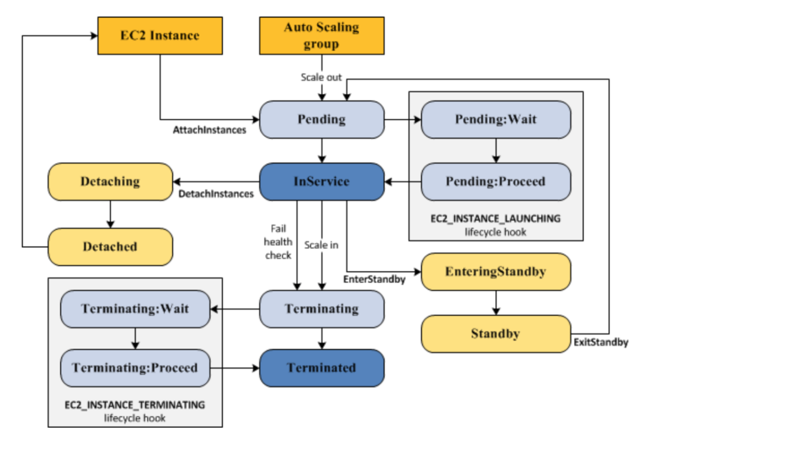

**Scale out :the following scale out Events direct the a.s group to launch ec2 instances and attach them to the group**

**-you manually increase the size of the group.**

**- you create a scaling policy to automatically increase the size f the group based n a specified increase in demand.**

**-you set up scaling by sceduled to increase the size of the group at aspecified time.**

**When a scale out event occurs, the a.s group launches the required no.of ec2 instances, using its assigned launch configuration.these instance start in the pending state.if u add a life cycle hook to your a.s group , you can perform a custom action here.**

**When each instance is fully configured and passes the amazon ec2 health checks, it is attached to the a.s group and it enters the in-service state.the instance is counted against the desired capacity of the a.s group.**

**Instance in service: instances remain in the I-service until one of the following occurs.**

**- a scale in event occurs and a.s chooses to terminates this instance in order to reduce the size of the a.s group.**

**-yo put the instance into a stand by state**

**- you detach the instance from the a.s group.**

**-the instance fails a required no.of health checks ,so it is removed the a.s group ,terminated and relaced.**

**Scale in : it is important that you create a scale in event for each scale out event that you create .this helps ensure that the resources assigned to your application match the demand for those resources as closely as possible .**

**The following scale in events direct the a.s group to detach ec2 instances from the group and terminate them .**

**- you manually decrease the size of the group.**

**-you create a scaling policy to automatially decrease the group based on a specified decrease in demand .**

**-you set up scaling by schdule to decrease the size of the group at a spacific time.**

**When a scale in event occurs , the a.s group detaches one or more instances . the a.s grou uses its termination policy to determine which instances to terminate.instances that are in the process of detaching from the a.s group and shutting down enter the terminatting state and cant be putback into service . if you add a life cycle hook to you’re a.s group , you can perform a cstom action here. Finally ,the instances are completely terminated and nter the terminated sate.**

**Attatch an instance :**

**You can attach a unning ec2 instance tha meets certain criteria to you’re a.s group.after the instance is attachd,it is managed as part of the a.s group.**

**Detach an instance :you can detach an instance from you’re a.s group. After the instance is detached, you can manage it separately from the a.s group or attach it to a different a.s group .**

**Auto scaling limits :**

**Launch config.per region-100**

1. **s groups per region -20**
2. **Scaling poicies per a.s group-50**
3. **Scheduled actions per a.s group-125**
4. **Life cycle hooks per a.s.g-50**
5. **Sns topics per a.s.g-10**
6. **Classic load balancers per a.s.g-50\***
7. **Target groups per a.s.g-50\***
8. **Step ajustments per scalling policy-20**